How to navigate links in MQL on 3DExp2015x between:
3DS.COM © Dassault Systèmes | Confidential Information | 5/23/14 | ref.: 3DS_Document_2014

- documents / references
- requirements / references

Written by: S.Quintin


- Description

The purpose of this document is to describe how to navigate in MQL between objects like :
- Documents and references
- Requirements and references
In R2015x, the persistence of the semantic relation has changed and evolved. This document tries to clarify the new persistence.
For example, the following R2013x query to search references linked to a given document fails in R2015x.
query connection type VPLMrel/VPMSemanticRelation where 'attribute[VPLMatt/VPMSemanticRelation/V_TargetPIDs]=="4C4F4F50000011E455C367180000005E" && to.type=="PLMDocConnection"' select to.physicalid dump |;
- My sample ref/doc data

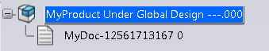
- My sample ref/doc data in database
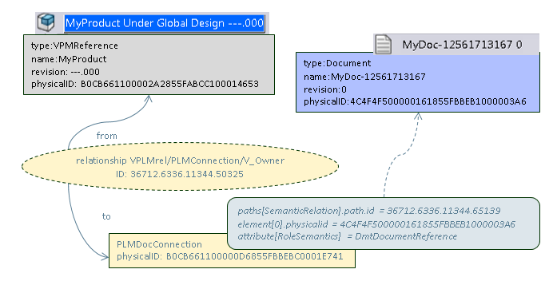

- How to obtain reference(s) from document?

1/ Print physical id of the document
MQL<3>print bus Document MyDoc-12561713167 0 select physicalid;
business object Document MyDoc-12561713167 0
physicalid = 4C4F4F500000161855FBBEB1000003A6

2/ Use query path to find the PLMDocConnection
MQL<4>query path type SemanticRelation ending with 4C4F4F500000161855FBBEB1000003A6 where "owner.type=='PLMDocConnection'" select owner.physicalid dump |;
SemanticRelation|B0CB661100000D6855FBBEBC0001E741

Syntax :
query path [type PATTERN] [vault PATTERN] [starting with SUBPATH | ending with SUBPATH | containing SUBPATH | subset of SUBPATH] [where EXPR] [orderby FIELD_NAME] [limit N] [SELECT] [DUMP] [RECORDSEP] [tcl] [output FILENAME]

3/ print semantic relation
MQL<5>print bus B0CB661100000D6855FBBEBC0001E741;
BusinessObject PLMDocConnection B0CB661100000D6855FBBEBC0001E741
lattice vplm
policy VPLM_SMB_CX_Definition
description
created 9/18/2015 9:35:25 AM
modified 9/18/2015 9:35:26 AM
…
relationship VPLMrel/PLMConnection/V_Owner
ID 36712.6336.11344.50325
meaning
from VPMReference MyProduct ---.000

- How to obtain document (s) from reference?

1/ Print the reference

MQL<4>print bus VPMReference MyProduct ---.000;
BusinessObject VPMReference MyProduct ---.000
lattice vplm
policy VPLM_SMB
description
created 9/17/2015 3:15:37 PM
…
relationship VPLMrel/PLMConnection/V_Owner
ID 36712.6336.11344.50325
meaning
to PLMDocConnection B0CB661100000D6855FBBEBC0001E741

2/ Print the found relation

MQL<5>print connection 36712.6336.11344.50325;
relationship VPLMrel/PLMConnection/V_Owner
from VPMReference MyProduct ---.000
from propagate modify false
to PLMDocConnection B0CB661100000D6855FBBEBC0001E741
to propagate modify false
…

3/ Print the found the PLMDocConnection extremity with paths filter

MQL<6>print bus B0CB661100000D6855FBBEBC0001E741 select paths[SemanticRelation].path.id;
business object PLMDocConnection B0CB661100000D6855FBBEBC0001E741
paths[SemanticRelation].path.id = 36712.6336.11344.65139

4/ Print the found path with filter on RoleSemantics

MQL<7>print path 36712.6336.11344.65139 select element.physicalid attribute[RoleSemantics];
path 36712.6336.11344.65139
element[0].physicalid = 4C4F4F500000161855FBBEB1000003A6
attribute[RoleSemantics] = DmtDocumentReference

5/ Print the found object

MQL<8>print bus 4C4F4F500000161855FBBEB1000003A6 select type name revision;
business object Document MyDoc-12561713167 0
type = Document
name = MyDoc-12561713167
revision = 0

- Requirement / reference
It’s the same principles except there are 2 paths on the connection object:
- One pointing back to the reference
- One pointing on the requirement

